A

PROJECT REPORT ON

Online Hair Salon System (reduce waiting time)

By

SHAH YASH (CE-144) (19CEUEG051) VAGHANI YASH (CE-170) (19CEUOS078) SAKHIYA VIDUR (CE-136) (19CEUOG101)

B.Tech CE Semester-VI Subject: System Design Practice

**Guided by:** Prof.Pandav K. Patel Assistant Professor Dept. of Comp. Engg.



Faculty of Technology Department of Computer Engineering

Dharmsinh Desai University



Faculty of Technology

Department of Computer Engineering

Dharmsinh Desai University

**CERTIFICATE**

This is to certify that the practical / **term work** carried out in the subject of

**System Design Practice** and recorded in this journal is the bonafide work of

SHAH YASH (CE-144) (19CEUEG051)

VAGHANI YASH (CE-170) (19CEUOS078)

SAKHIYA VIDUR (CE-136) (19CEUOG101)

of B.Tech semester **VI** in the branch of **Computer Engineering**

during the academic year **2021-2022**.

Prof. Pandav K. Patel Dr. C. K. Bhensdadia,

Assistant Professor, Head,

Dept. of Computer Engg., Dept. of Computer Engg.,

Faculty of Technology Faculty of Technology

Dharmsinh Desai University, Nadiad Dharmsinh Desai University, Nadiad

Contents

**Abstract** 3

**Introduction** 4

**SOFTWARE REQUIREMENTS SPECIFICATION (SRS)** 5

**DESIGN** 9

**Use Case Diagram** 9

**Sequence Diagram** 10

**Data-Flow Diagram** 12

**ER Diagram** 15

**Data Dictionary** 16

**Implementation Details** 19

**Testing** 22

**Test Cases** 22

**screenshots** 23

**Conclusion** 33

**Limitation and Future Enhancement** 33

**Reference / Bibliography** 34

# Abstract

There is lot of Platforms for the restaurant industry, but nothing quite like this existed to bring clients and beauty salons together online. Our WebApp **online hair salon system** fills this void in a way that is easy to use and effective for users and salon managers.

Nowadays time is more costly than money so waiting for hours and hours to get hair cut is not affordable. That’s why our application reduces waiting time by showing number in queue and approximate time to customer. Customer can find best salon as per rating of salon and also give rate to salon for improve salon credit.

Owners can improve number of customers by publishing salon in our application. Owner can easily manage customers, stylist and services.

# Introduction

* About Project:

Online hair salon system (reduced waiting time) is a web-based salon management application with booking scheduling functionality. It connects clients, salons, and stylists in an online community allowing users to browse salons and stylists, and book appointment. Users can also give and read rating of salons. Salon Owners can specify the stylists that work at their salons and the services provided by salon.

Our application includes Some of the major use cases user account registration, login/logout, List of nearby salons in the range of 50km, booking of seat, view Orders history, give rating of completed orders at customer side. Queueing customer, manage stylists, services and salon details at Owner side. Inspection and verification of salon at admin side.

* Technology:

My project uses MongoDB Atlas and Express-js to back the interface with strong database functionality and React Framework as frontend. Online hair salon system integrates Cloudinary as a cloud storage for Dynamic image upload, google map picker for view map and Nodemailer for mailing.This project will target the major web browsers as the initial platform.

* Tools:
* Visual Studio Code (editor)
* MongoDb compass
* Github

# **SOFTWARE REQUIREMENTS SPECIFICATION (SRS)**

**Online Hair Salon System (reduce wait time)**

**R 1: User side**

**Description:** User can see only nearby salon list if user want to see full details and wants to book seat then user must sign in to system.

**R 1.1: Authentication**

**Description:** If user is new to the system then First he/she must sign up to the system otherwise user can directly login and then enter to the system.

**R 1.1.1: Sign Up**

**Input:** User details.

**Process:** Validate details.

**Output:** Redirect to OTP verification page.

**R 1.1.2: Sign In**

**Input:** User details.

**Process:** Validate details.

**Output:** Redirect to Home page.

**R 1.1.3: Log Out**

**Input:** User Selection.

**Output:** Redirect to Home page.

**R 1.2: Salon Details**

**Description:** as per user selectionsystem shows salon details view

**R 1.2.1: Hair Services**

**Input:** User selection.

**Output:** list the all-hair services.

**R 1.2.2: About**

**Input:** User selection.

**Output:** Show Salon and Owner details.

**R 1.2.3: Employee Details**

**Input:** User selection.

**Output:** Show Employee Details of salon.

**R 1.2.4: Book Seat**

**Input:** User Selection.

**Process Set:** Show summary Page

**Process:** User Confirmation.

**Output:** Mail Sent to user email, Confirmation message show.

**R 1.3: Orders History**

**Description:** it will show list and status of all orders.

**R 1.3.1: Rating**

**Description:** Only Completed Orders are Rated by User.

**Input:** User selection.

**Process:** add rated star to salon.

**Output:** Confirmation Message.

**R 1.4: List Near By Salon**

**Description:** Display all salon near by user’s current location

**Input:** User’s location.

**Process:** Find distance user’s current location to salon’s location.

**Output:** List of nearby salons.

**R 2: Owner Side**

**Description:** Owner First have to sign up to system and then register for Salon, admin review the salon and then after approval by admin Owner enter in to Owner Home page.

**R 2.1: Authentication**

**Description:** If user is new to the system then First he/she must sign up to the system otherwise user can directly login and then enter to the system.

**R 2.1.1: Sign Up**

**Input:** User details.

**Process:** Validate details.

**Output:** Redirect to Salon Register.

**R 2.1.2: Sign In**

**Input:** User details.

**Process:** Validate details.

**Output:**

1) if salon not registered then redirect to salon registration.

2) if salon registered and under verification then redirect to verification status.

3) otherwise redirect to owner home page.

**R 2.1.3: Register Salon**

**Input:** User details.

**Process:** Validate details.

**Output:** Redirect to Verification status Page.

**R 2.1.4: Log Out**

**Input:** User Selection.

**Output:** Redirect to Home page.

**R 2.2: Manage Customer**

**Description:** it shows list of customers in queue.

**R 2.2.1 Complete Order**

**Input:** User selection.

**Output:** Customer Remove from list.

**R 2.2.2 Cancel Order**

**Input:** User selection.

**Output:** Customer Remove from list.

**R 2.3: Manage Employee**

**Description:** it shows list of Employee.

**R 2.3.1 Add Employee**

**Input:** Detail.

**Process:** it checks the capacity of salon.

**Output:** Employee Added to list.

**R 2.3.2 Edit Employee**

**Input:** Employee Details.

**Output:** list updated.

**R 2.3.3 Delete Employee**

**Input:** User selection.

**Output:** Employee removed from list.

**R 2.4: Manage Hair Services**

**Description:** it shows list of Hair Services as per category.

**R 2.4.1 Add Service**

**Input:** Details.

**Output:** Service Added to list.

**R 2.4.2 Edit Service**

**Input:** Details.

**Output:** list updated.

**R 2.4.3 Delete Employee**

**Input:** User selection.

**Output:** Service removed from list.

**R 3: Admin Side**

**Description:** Admin First have to sign into system then he/she will be redirect to page which shows the list of requested salon registration.

**R 3.1: Salon Details**

**Input:** User selection.

**Output:** show Details of salon.

**R 3.2: Approve Salon Registration**

**Input:** User selection.

**Process:** Salon Registration is approved.

**Output:** salon removed from list.

**R 3.3: Reject Salon Registration**

**Input:** User selection.

**Process:** Salon Registration is Rejected.

**Output:** salon removed from list.

# **DESIGN**

## **Use Case Diagram**

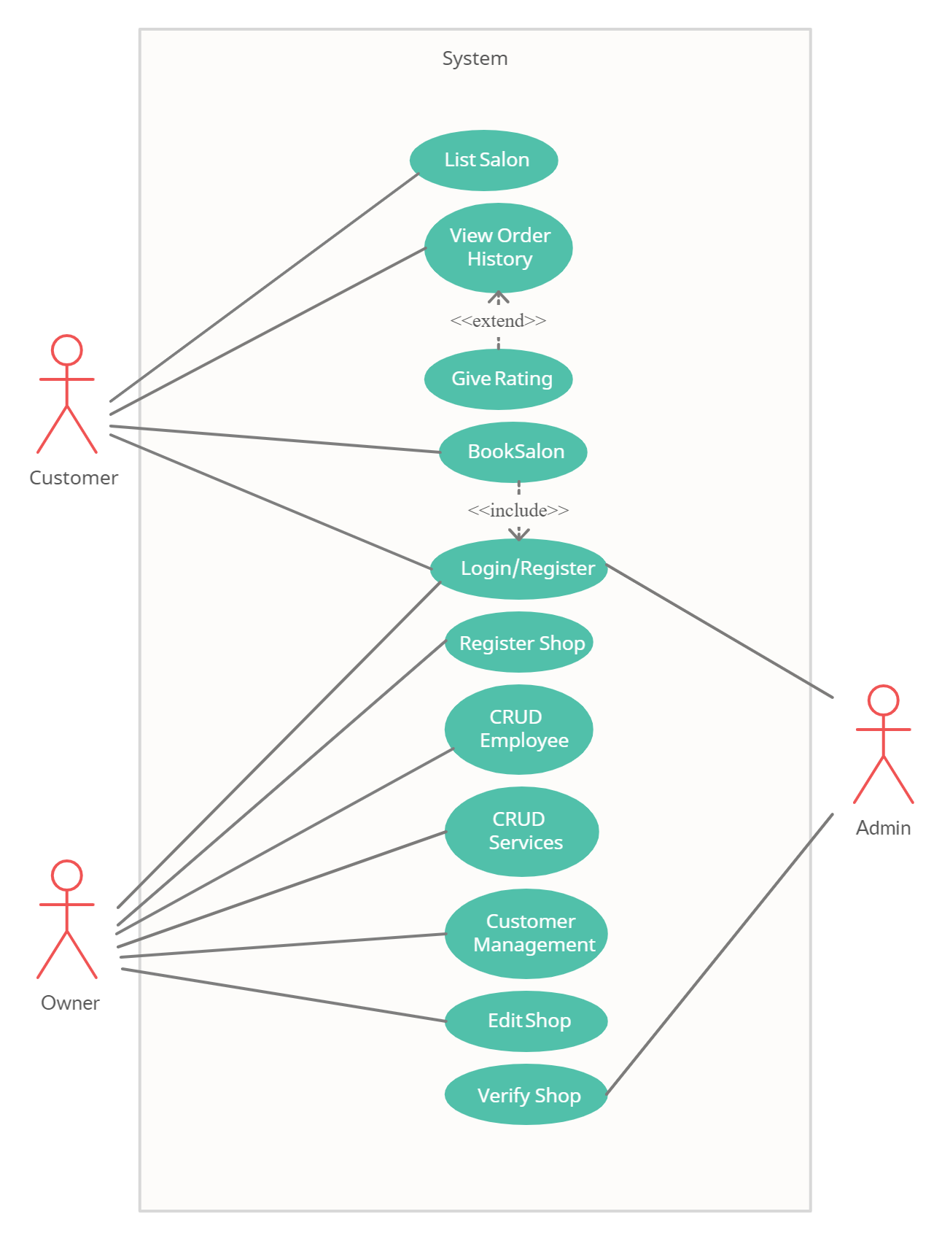

## **Sequence Diagram**

**1) Seat Booking**

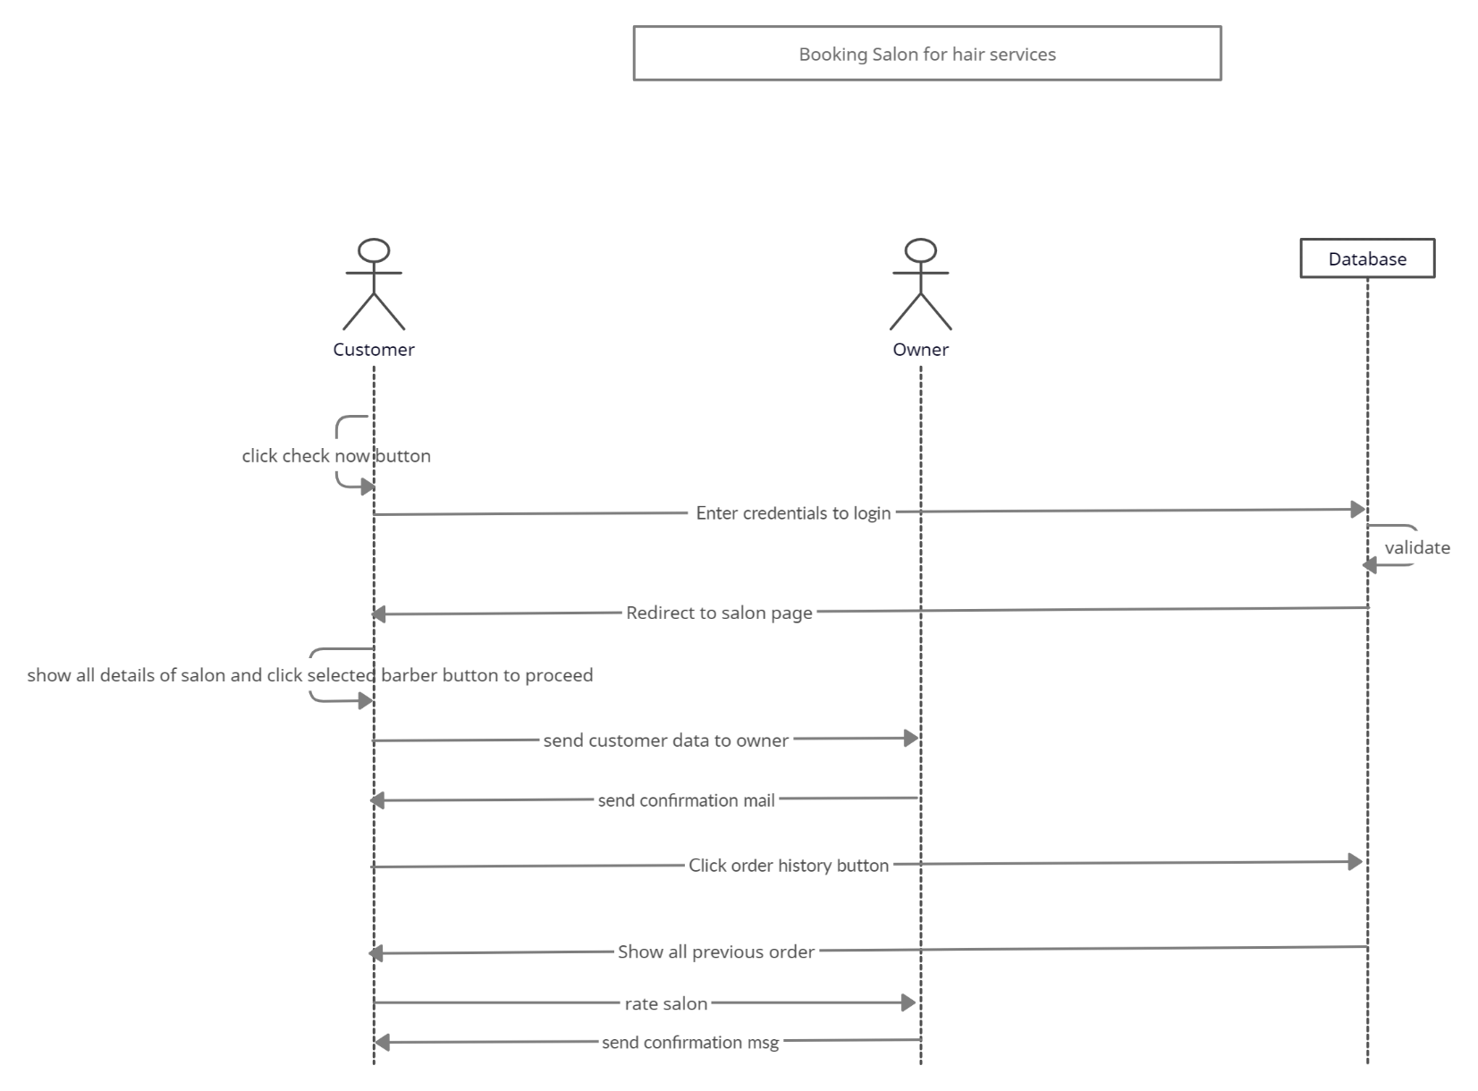

**2) Sequence Of Owner Interface**

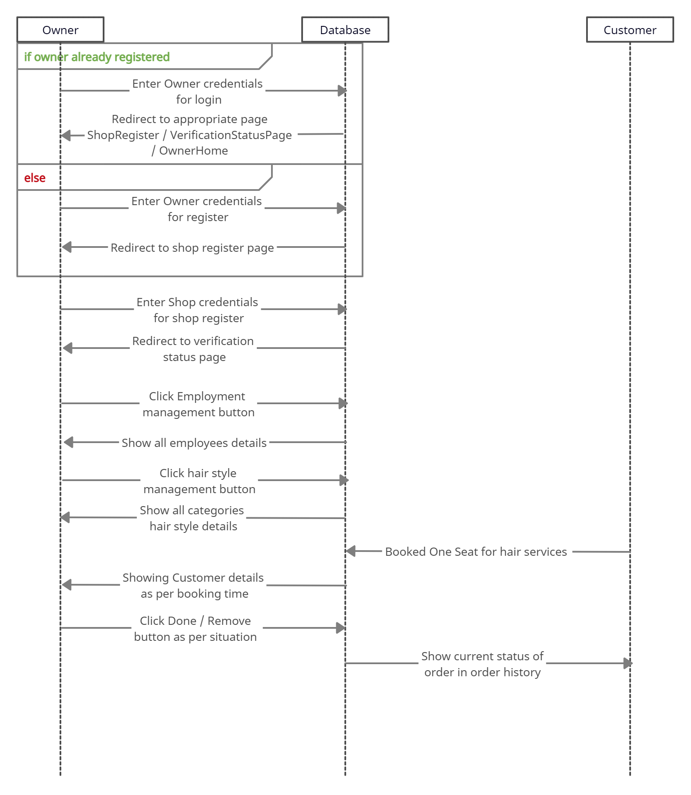

## **Data-Flow Diagram**

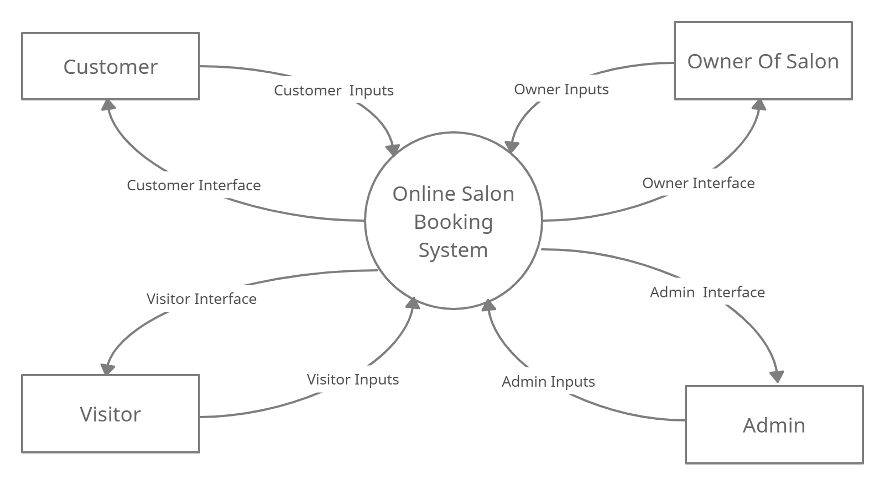

**Level - 0**

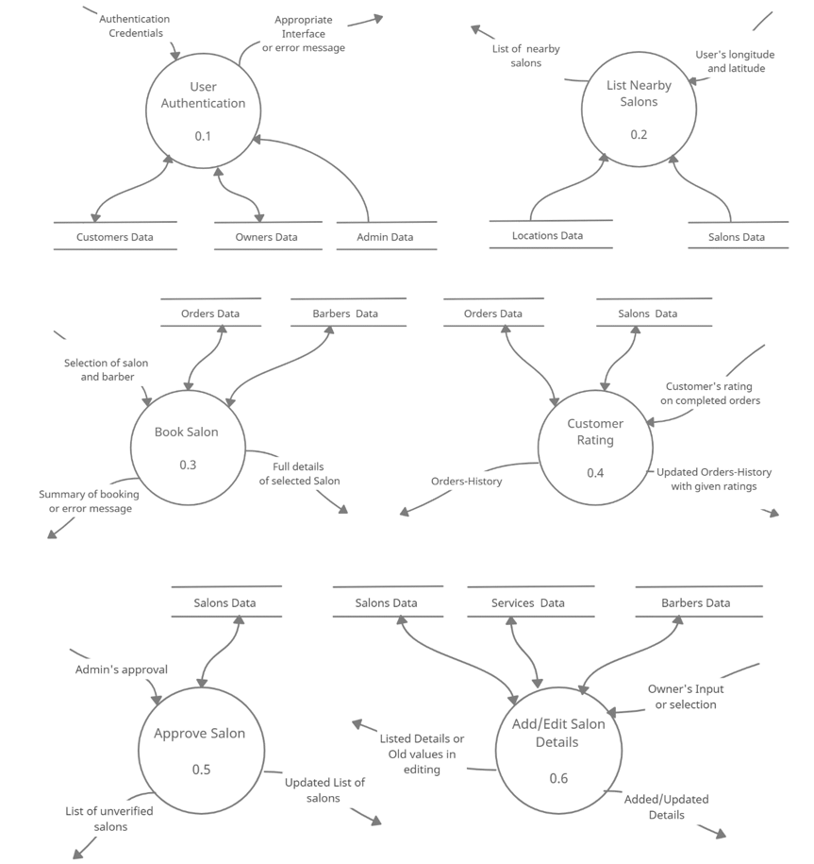

**Level – 1**

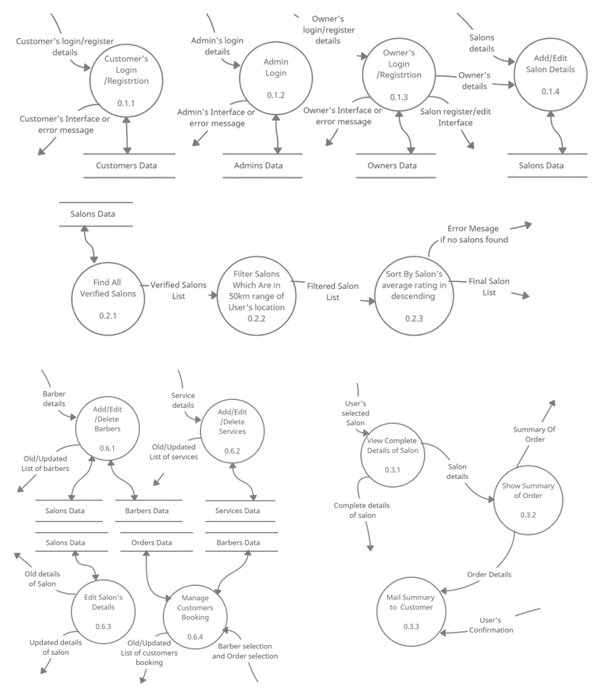

**Level - 2**

## **ER Diagram**

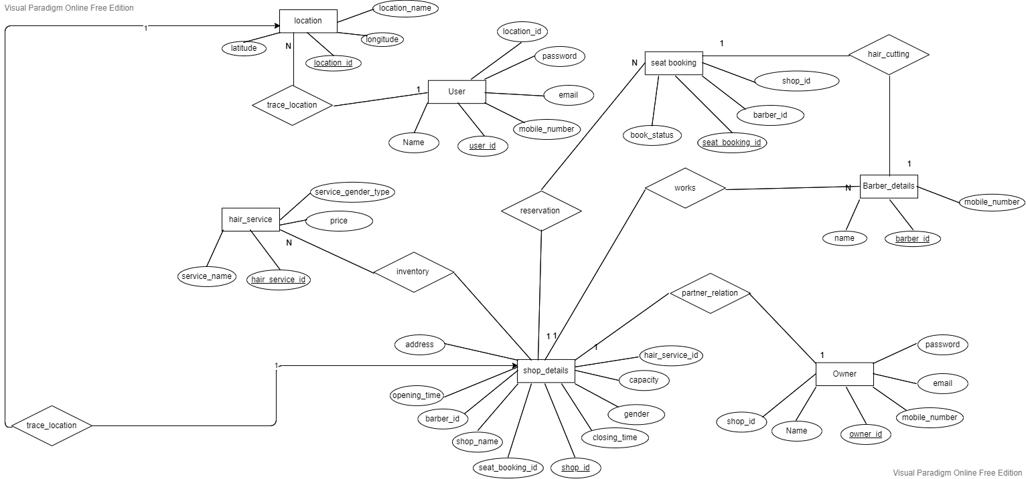

## **Data Dictionary**

**Tables**

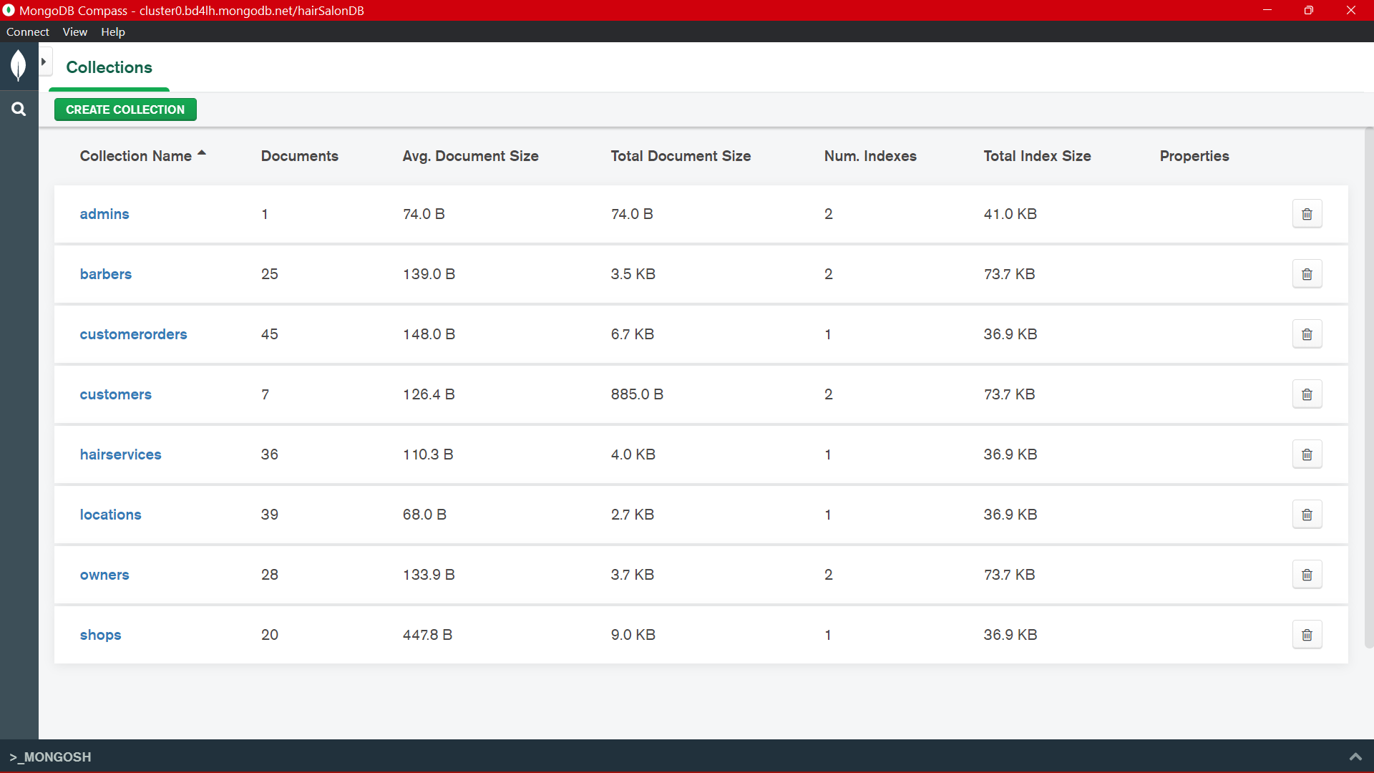

**Admin:**

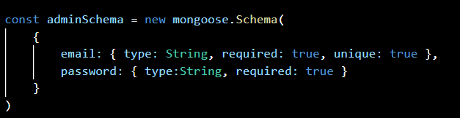

**Barber:**

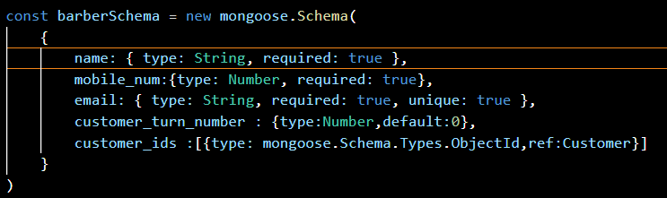

**Customer:**

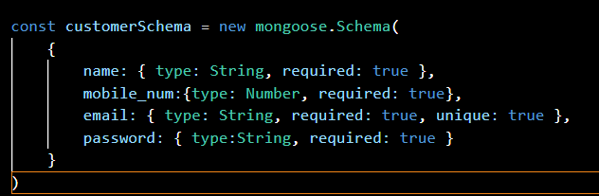

**CustomerOrders:**

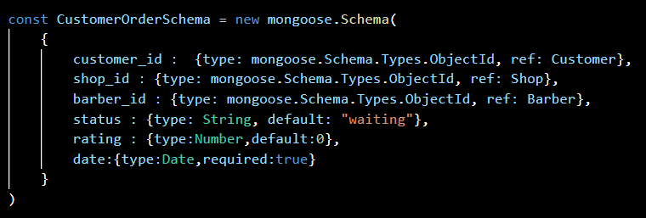

**HairService:**

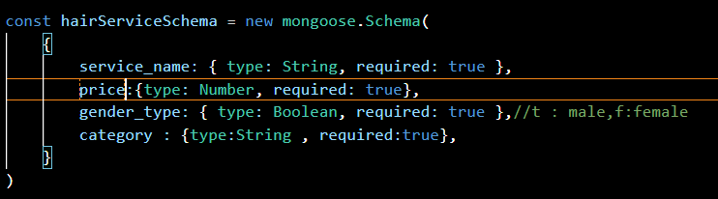

**Location:**

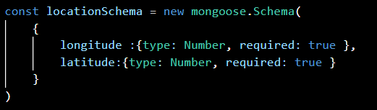

**Owner:**

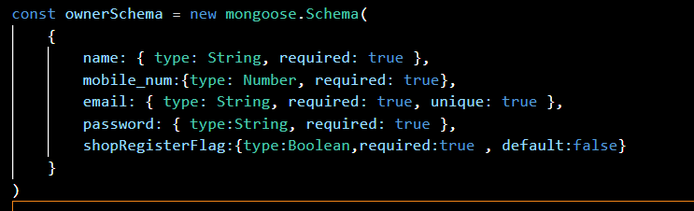

**Shop(salon):**

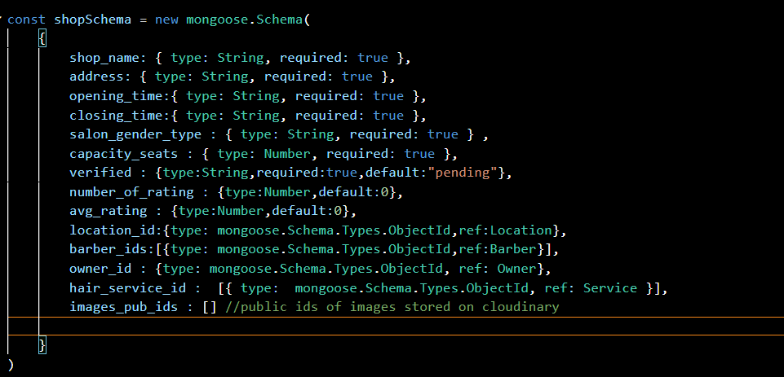

# **Implementation Details**

* **Modules created and brief description of each module**

This Project consists of 4 major modules.

1. User Module
2. List Nearby Salon Module
3. Rating Module
4. Salon Details Management Module

Each module consists of several methods to implement the required functionality Implementation is done using MERN.

1. **User Module**

There are three types of Users: Admin, Owner, Customer. This module is the base for authentication and authorization to ensure the security aspect of the user.

1. **List Nearby Salon Module**

In this module it finds salons in range of 50km as per user’s current location by finding distance between salons and user’s location (longitude, latitude) and sort salon list by average rating.

1. **Rating Module**

In this module customer can give rating to their completed orders which is also reflected in salon’s average rating.

1. **Salon Details Management Module**

In this module Owner can update salon’s details (i.e. address, photos etc..). Owner can manage all details of Customer appointments, services and Employees.

* **Function prototypes which implement major functionality**

1. List salon

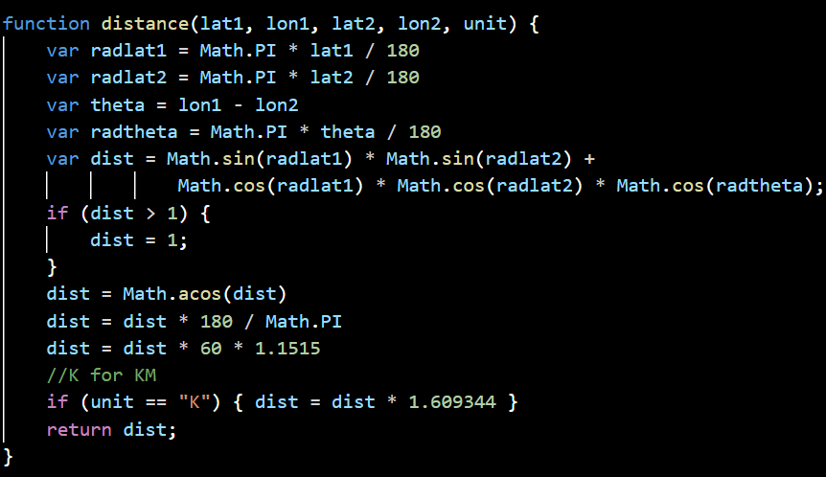

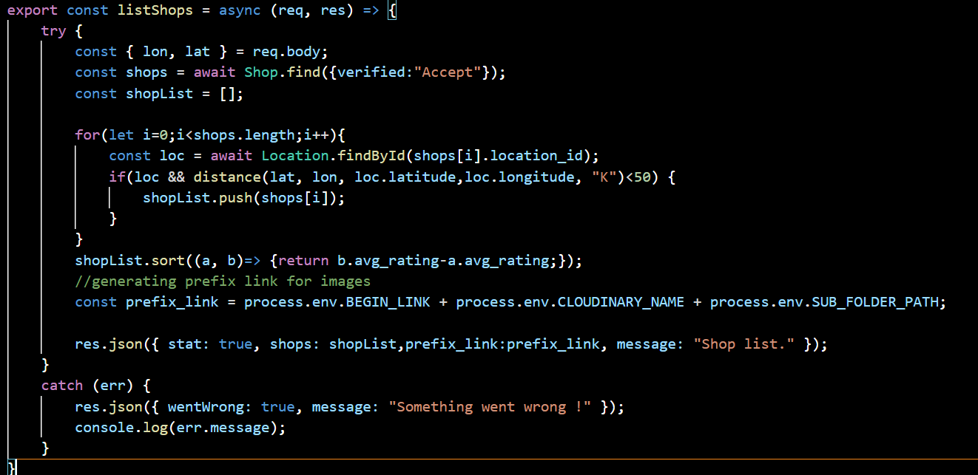

1. Rating Module

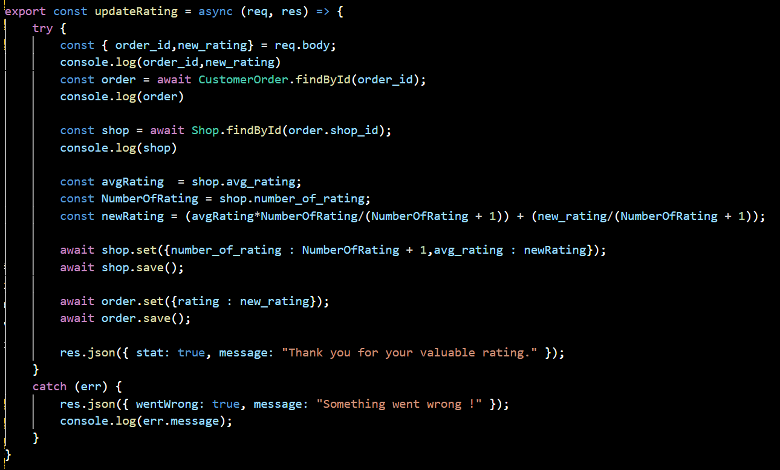

3)Edit Shop

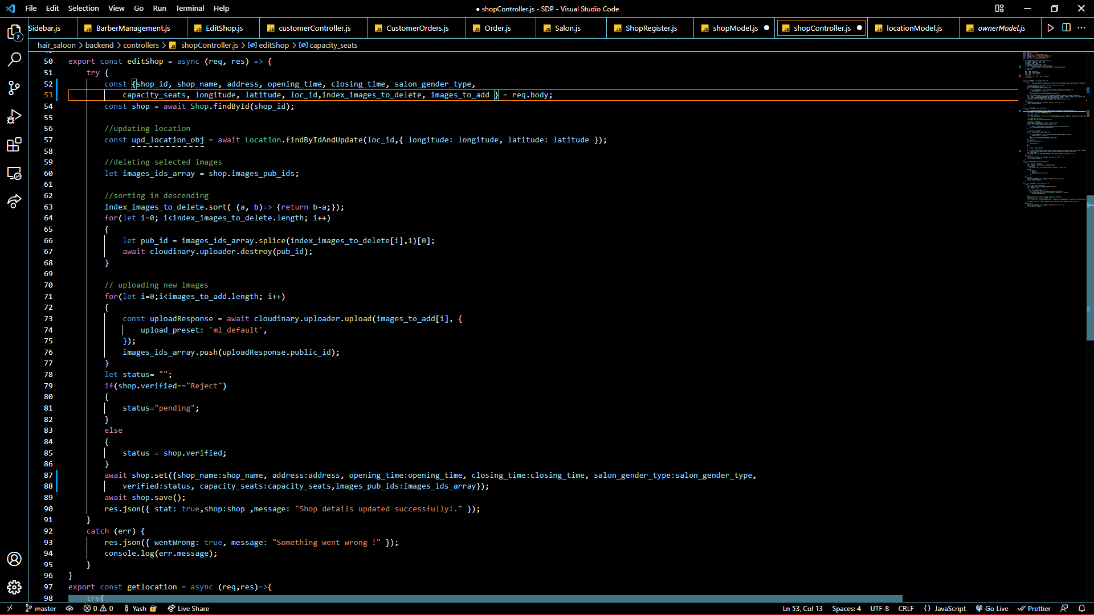

* **Project Structure**

# **Testing**

## **Test Cases**

|  |  |  |  |  |  |  |
| --- | --- | --- | --- | --- | --- | --- |
| Test Case Id | SRS Id | Test Case Objective | Input Data | Expected Output | Actual Output | Status |
| TC_01 | R 1.1  R 2.1 | Authentication of customer and owner | Credential | Success or error message | Success or error message | Pass |
| TC_02 | R 1.2 | Salon Detail | Selection of salon | Full detail of salon | Full detail of salon | Pass |
| TC_03 | R 1.2.4 | Book seat | Stylist selection | Summary mail and message | Summary mail and message | Pass |
| TC_04 | R 1.3.1 | Rating | Customer’s rating | Confirmation message | Confirmation message | Pass |
| TC_05 | R 1.4 | List Salon | Customer’s location | List of nearby salons | List of nearby salons | Pass |
| TC_06 | R 2.2 | Manage Customer appointments | Selection of stylist and customer | Confirmation message | Confirmation message | Pass |
| TC_07 | R 2.3 | Manage Employees | Employee Details or selection | Confirmation message | Confirmation message | Pass |
| TC_08 | R 2.4 | Manage Services | Service Details or selection | Confirmation message | Confirmation message | Pass |
| TC_09 | R 3.1 | Inspections Of Salon Details | Selection of Salon | Salon Details | Salon Details | Pass |
| TC_10 | R 3.2 | Approve Salon | Selection of salon | Confirmation message | Confirmation message | Pass |
| TC_11 | R 3.3 | Reject Salon | Selection of salon | Confirmation message | Confirmation message | Pass |

# **screenshots**

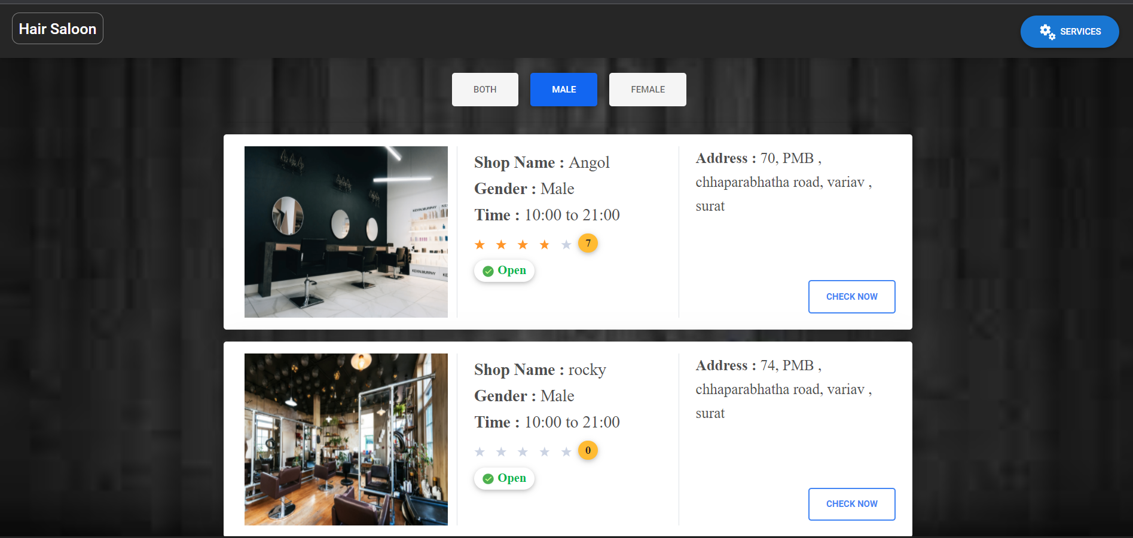**Customer Interface:**

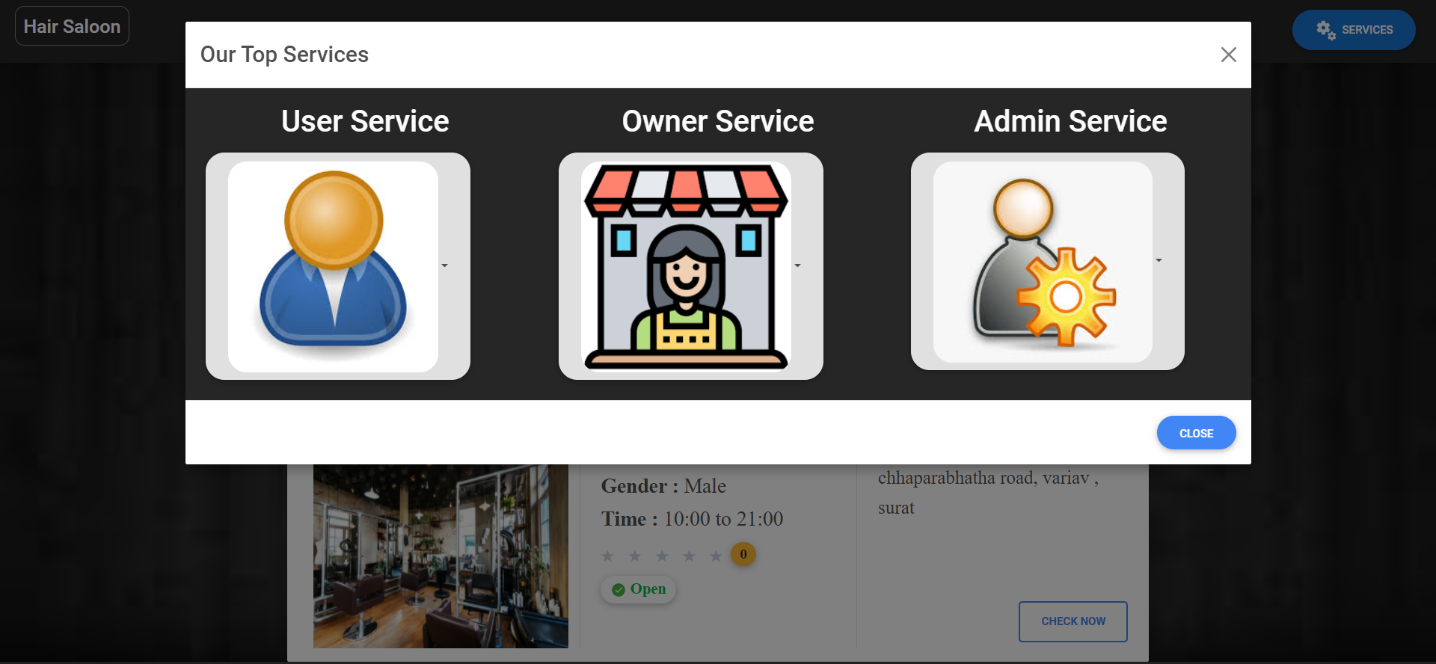

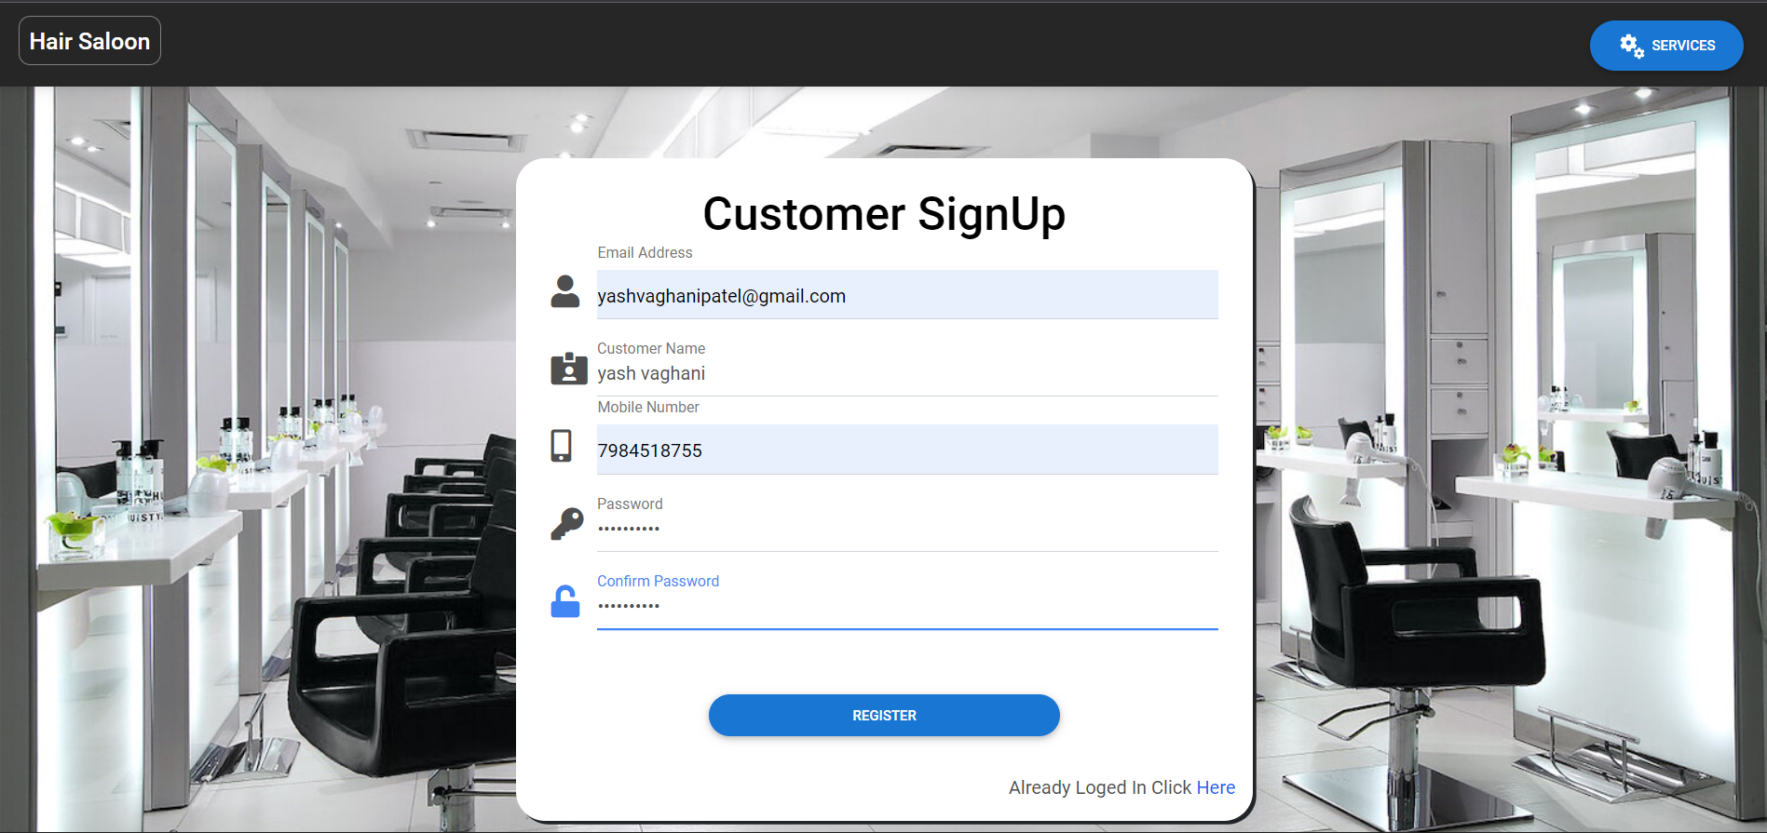

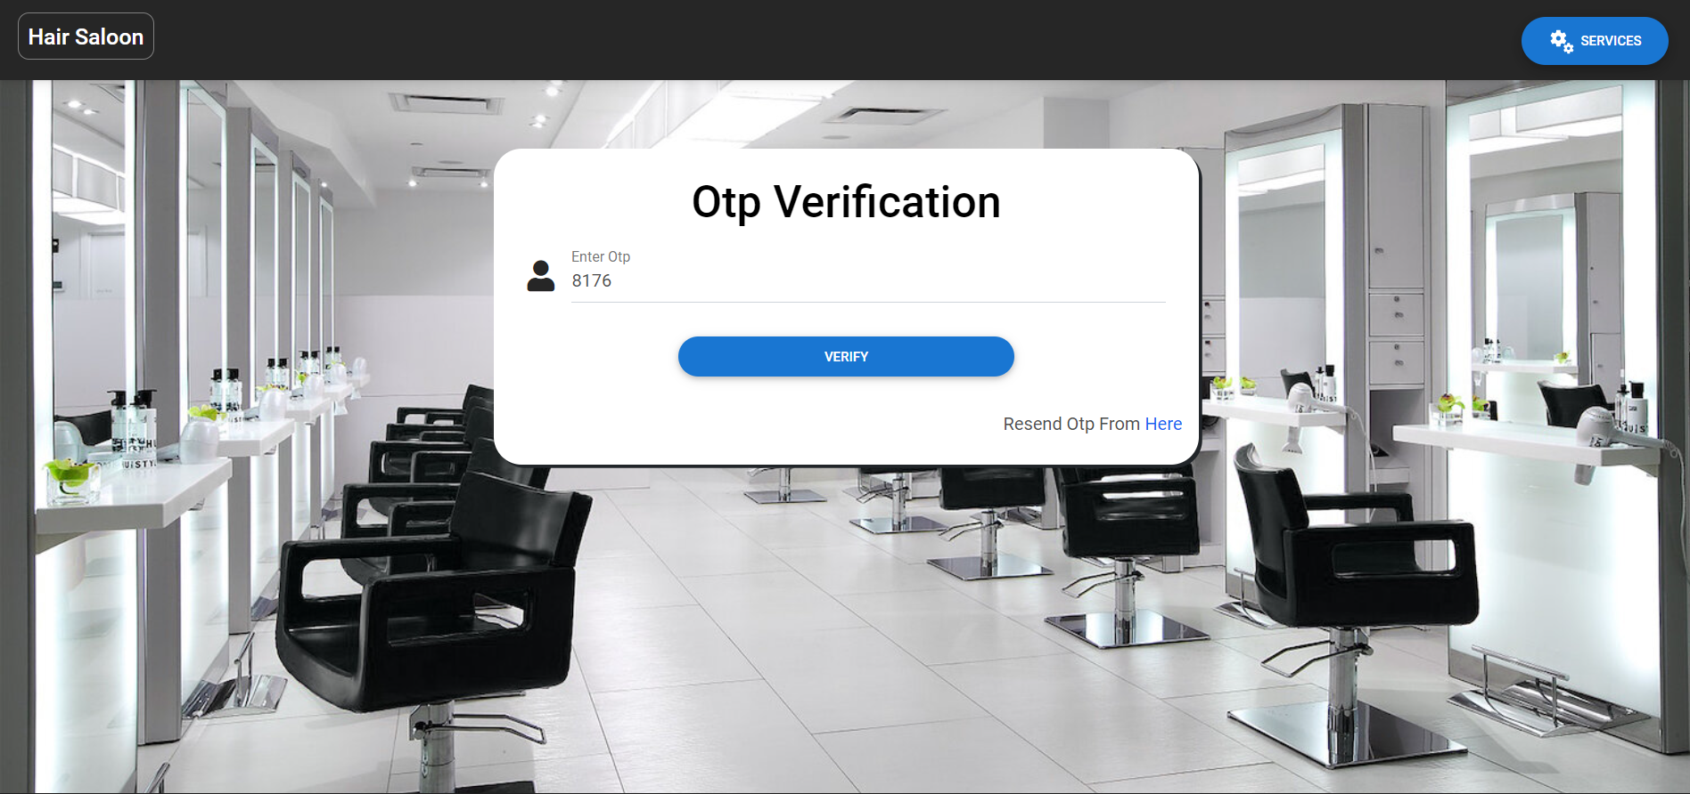

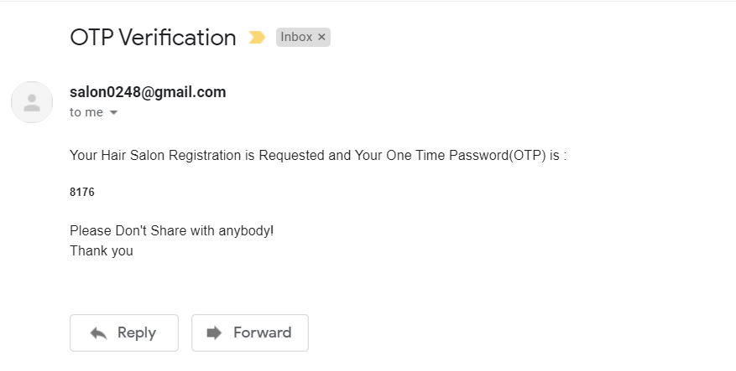

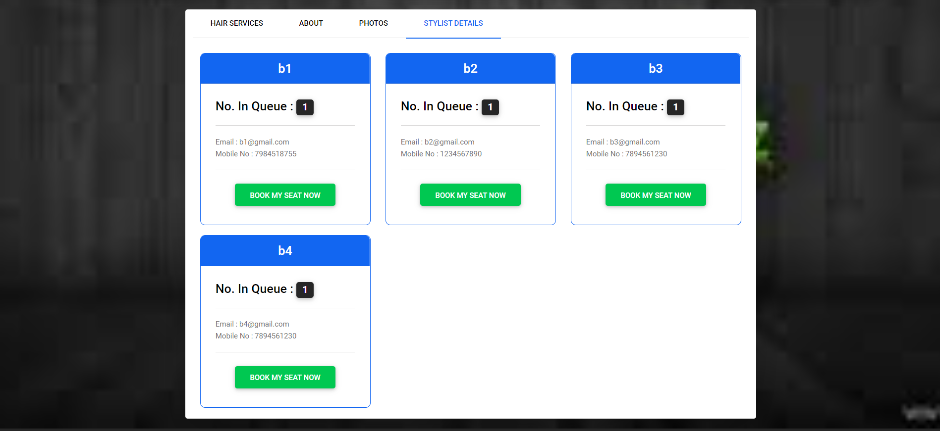

**Salon details view:**

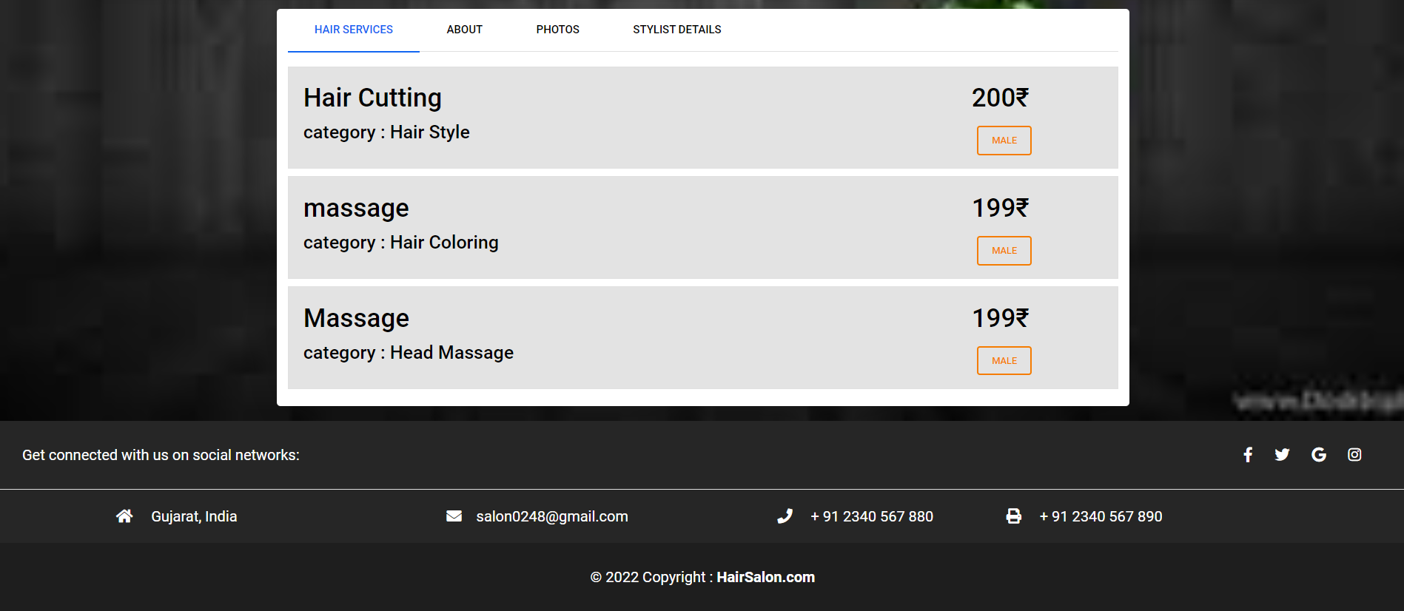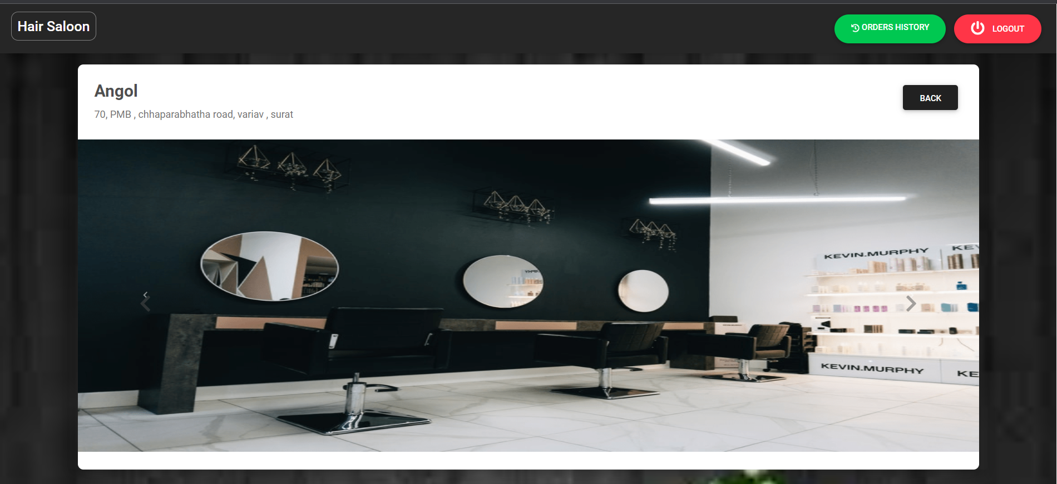

**After selecting stylist:**

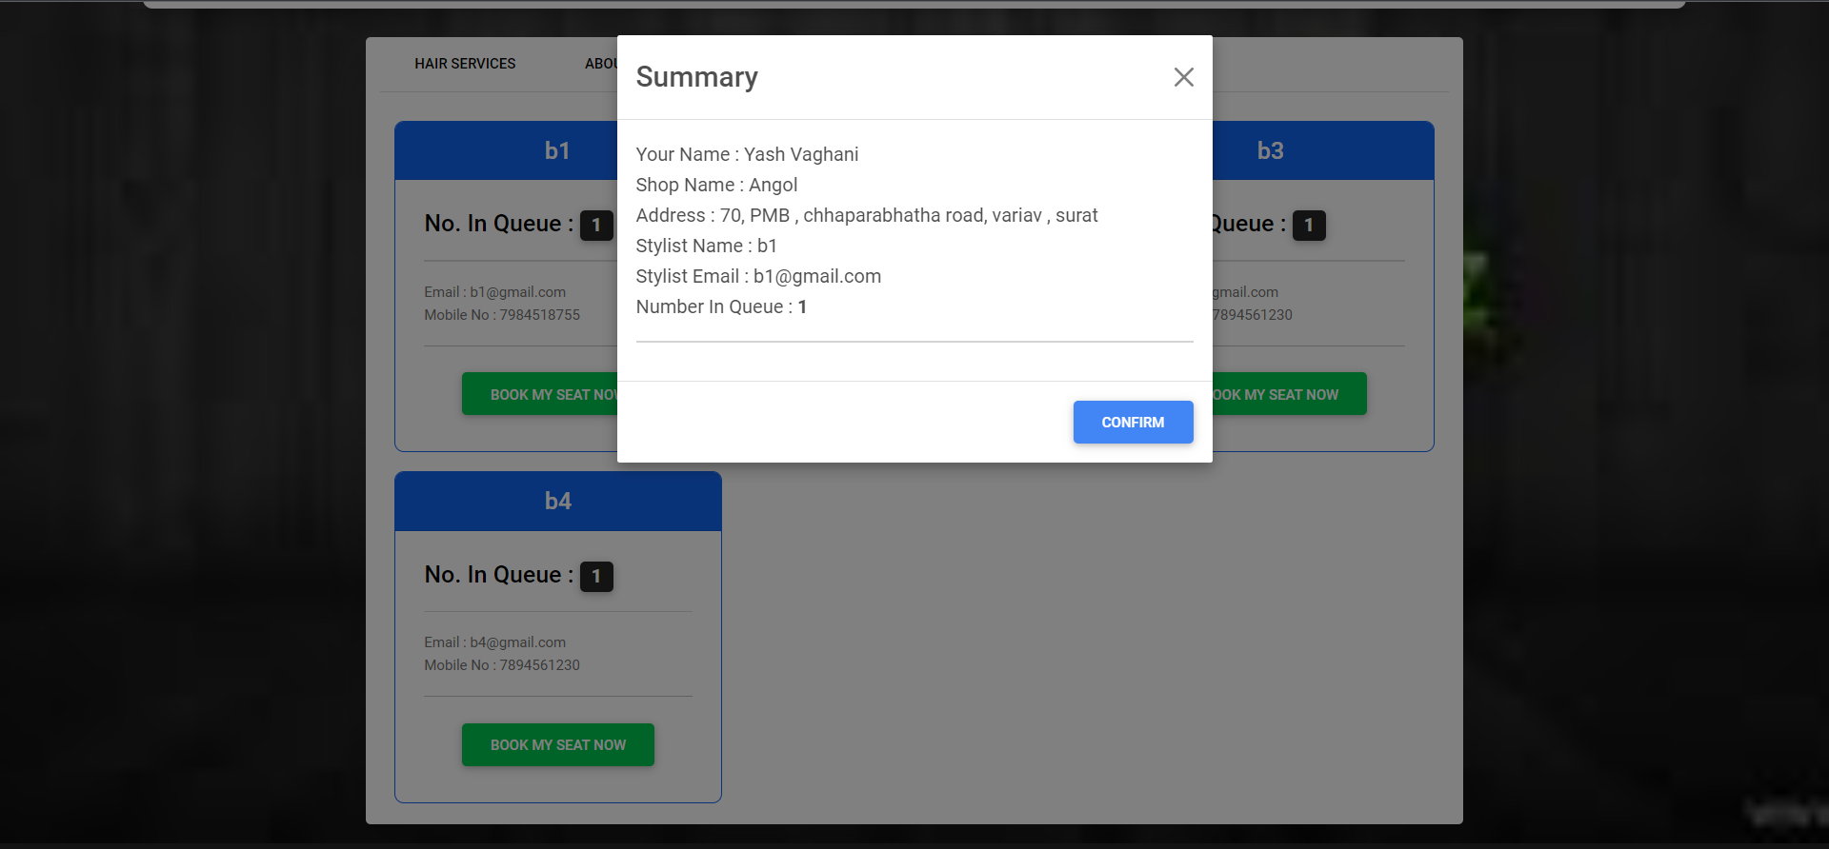

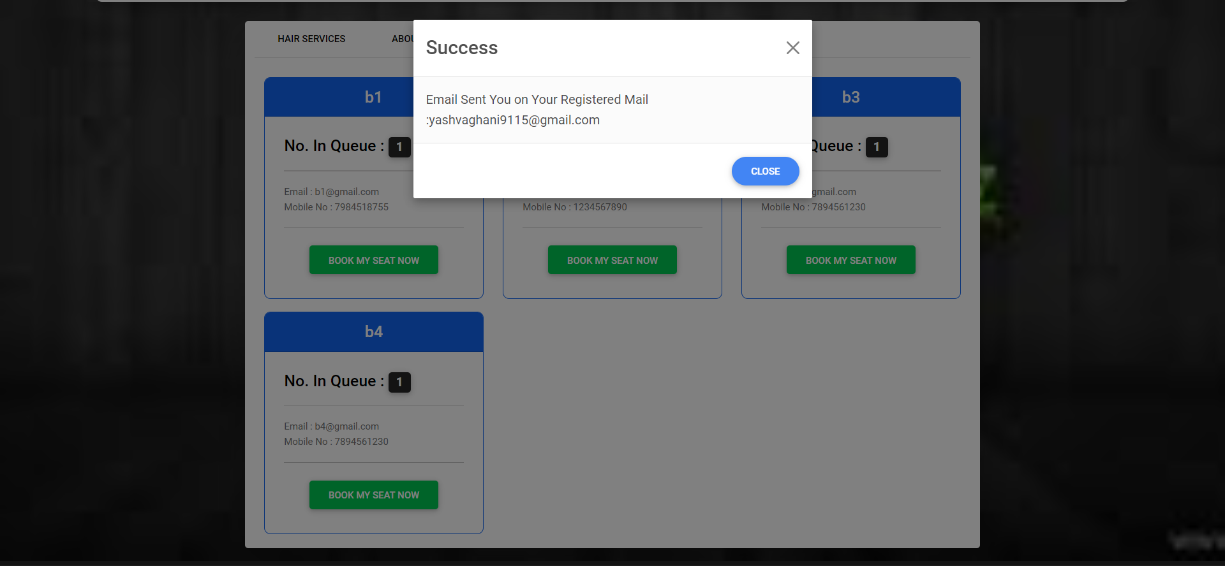

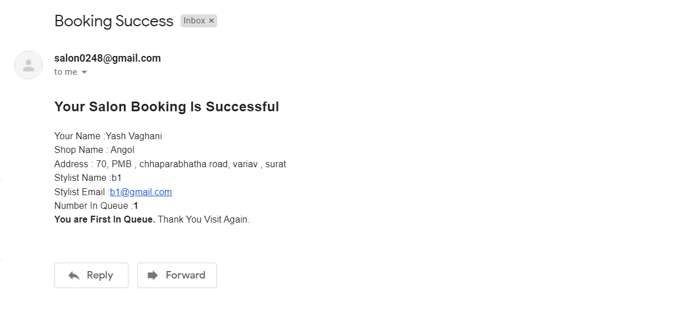

**Order History:**

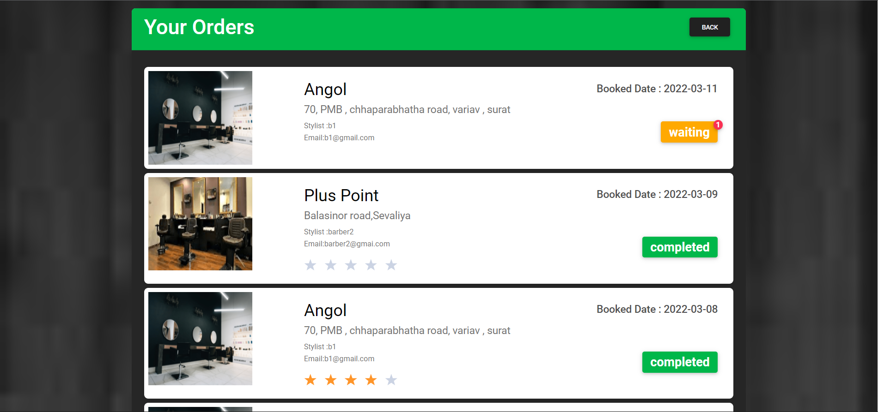

**Owner Interface:**

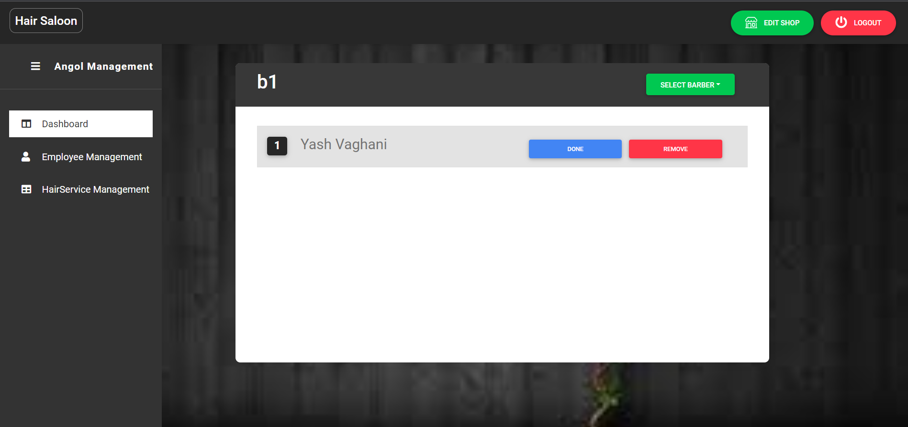

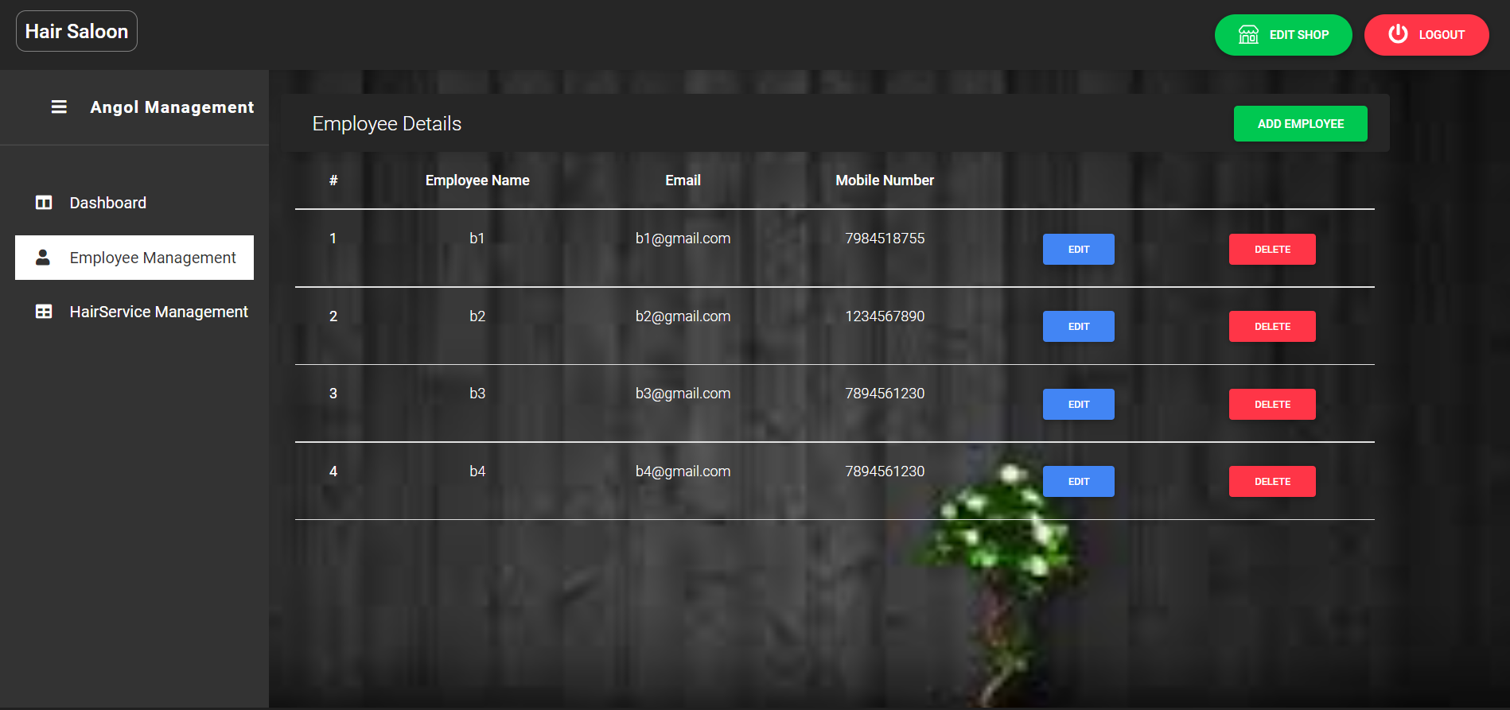

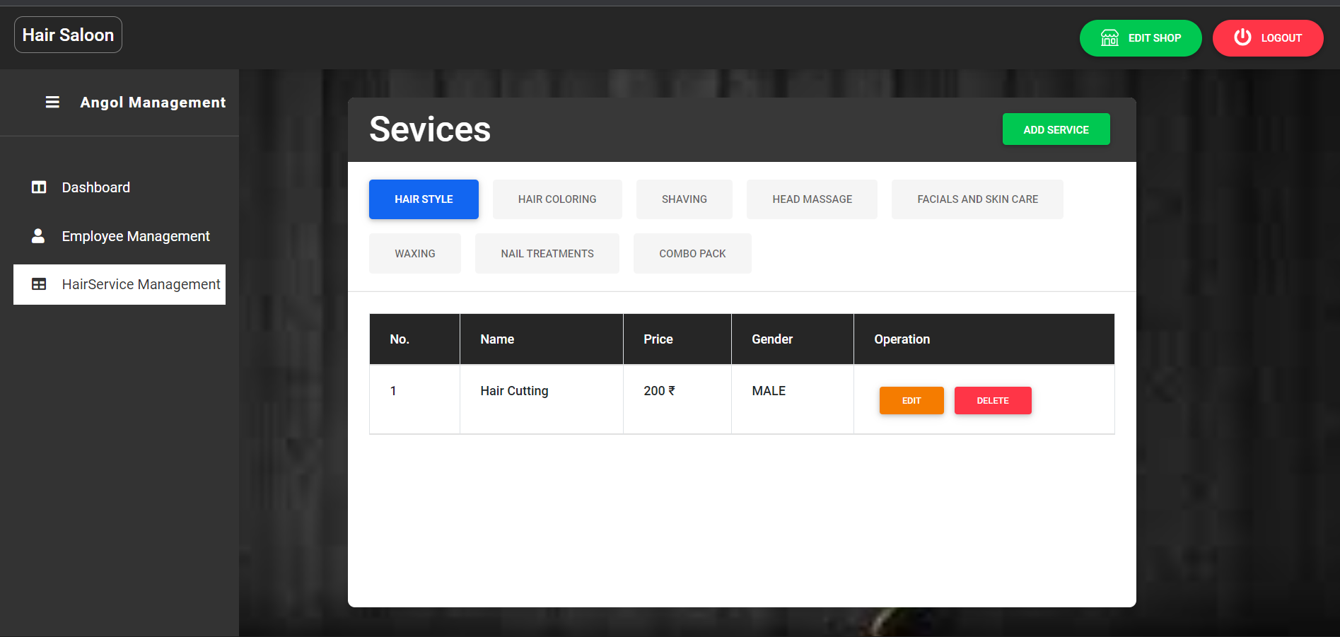

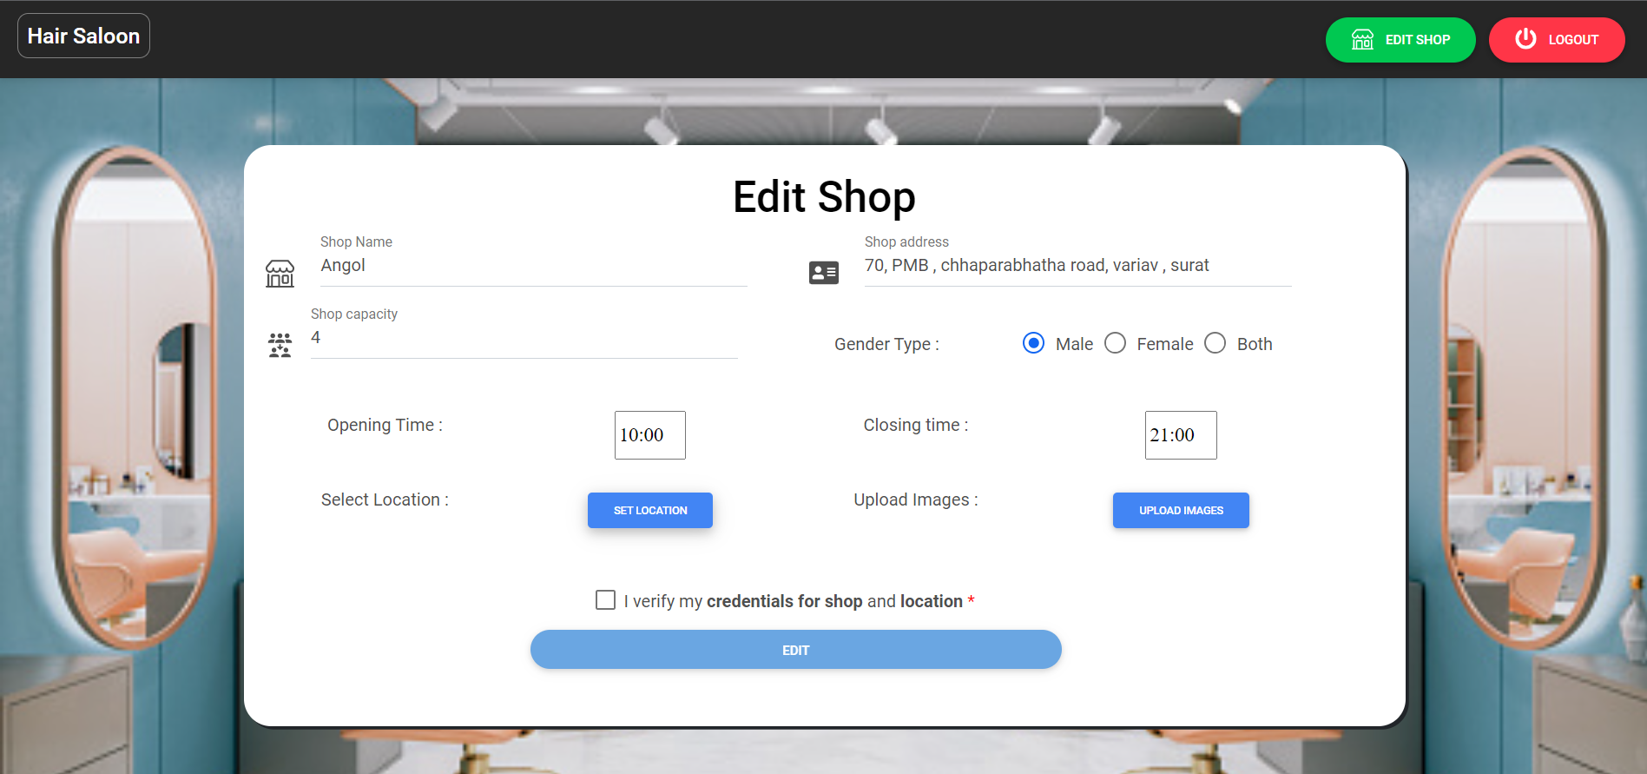

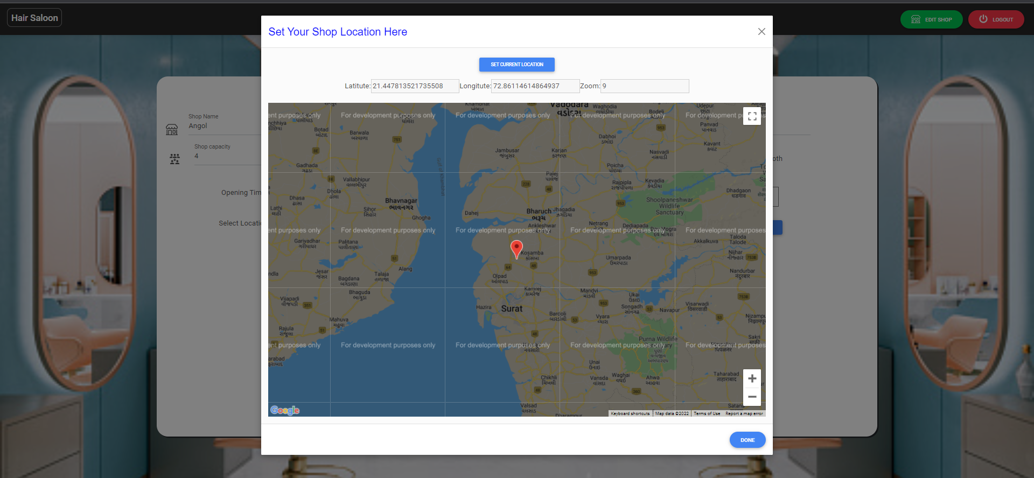

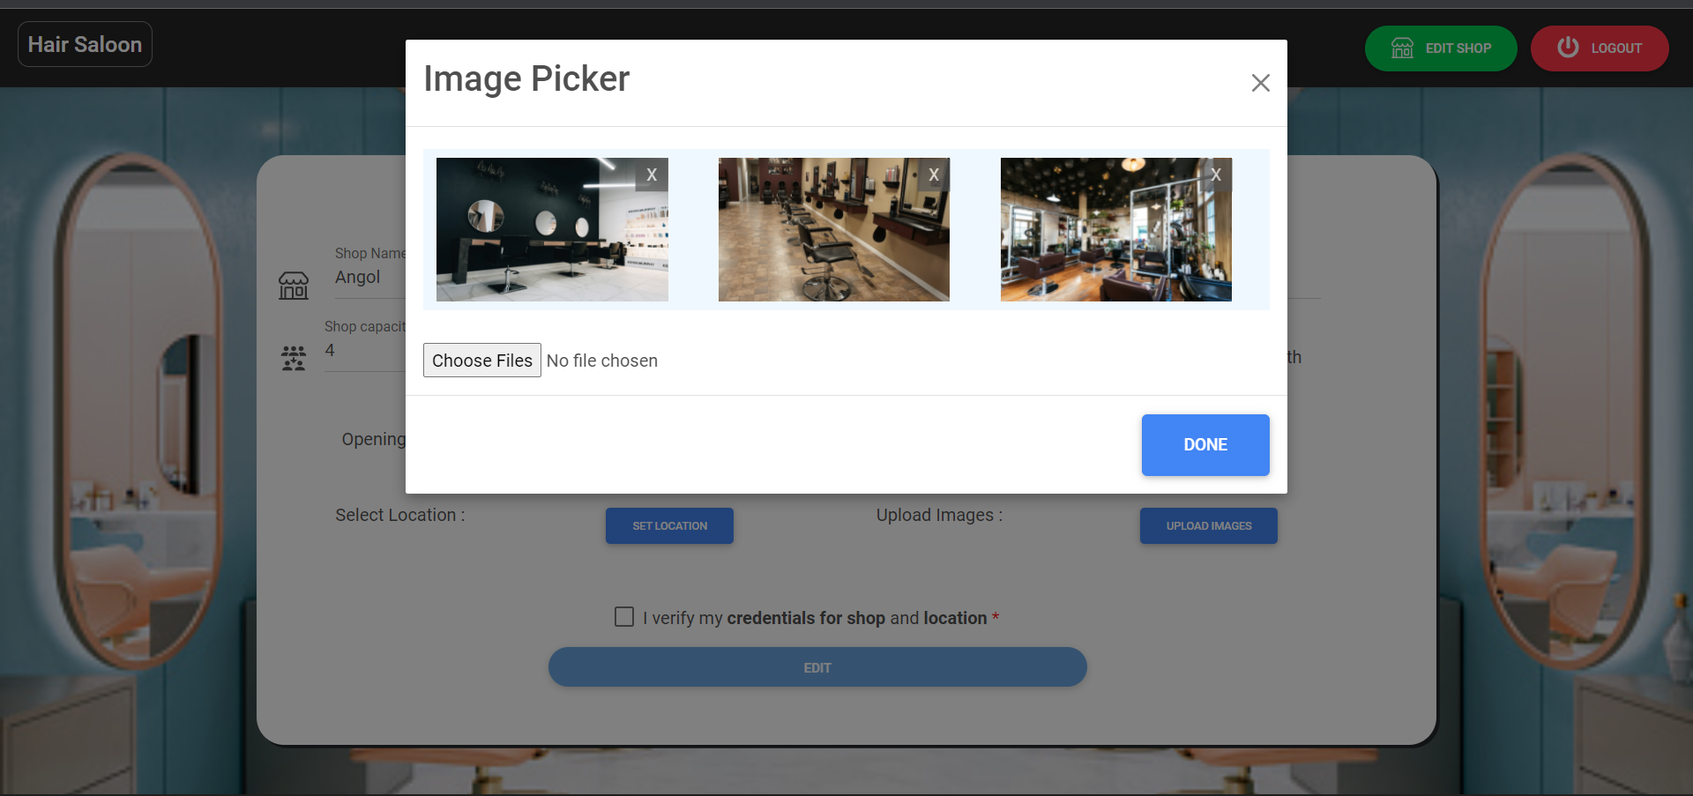

**Admin Interface:**

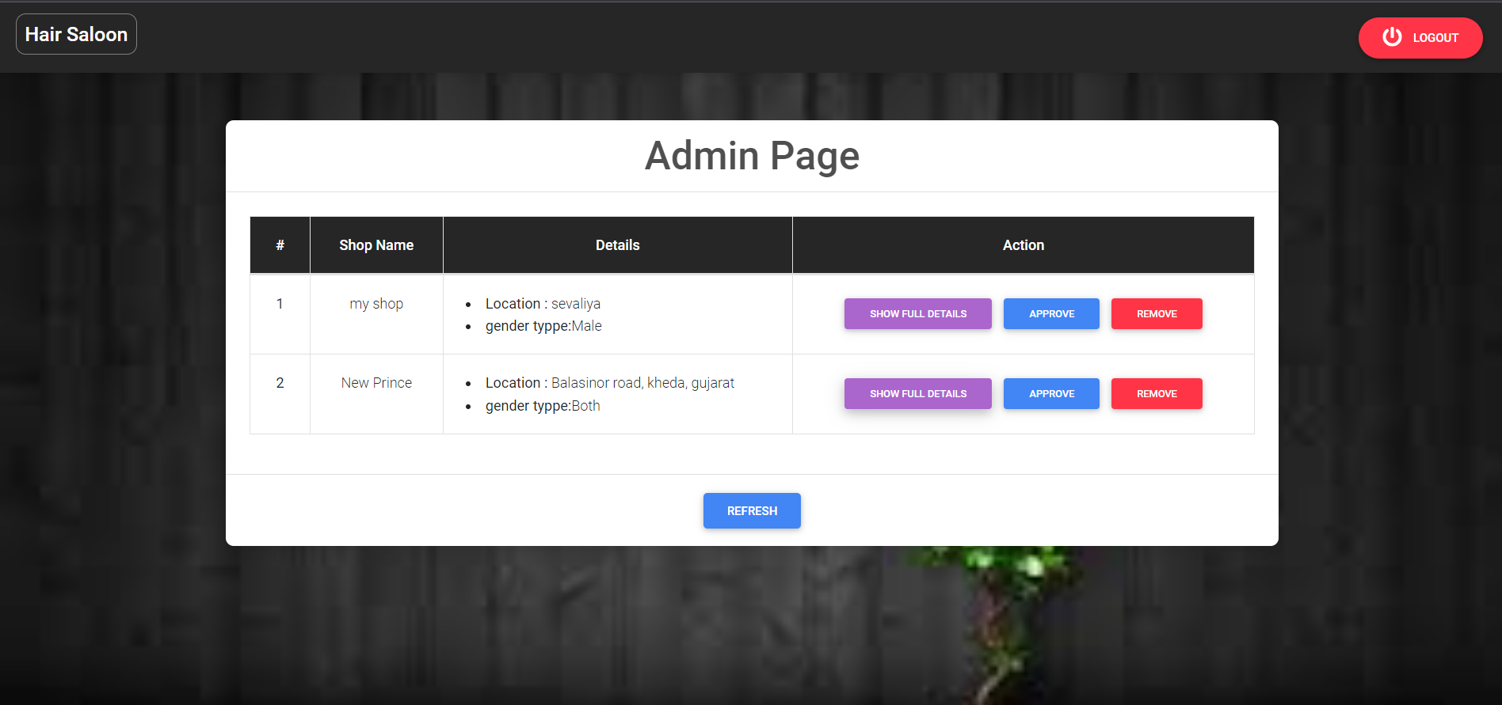

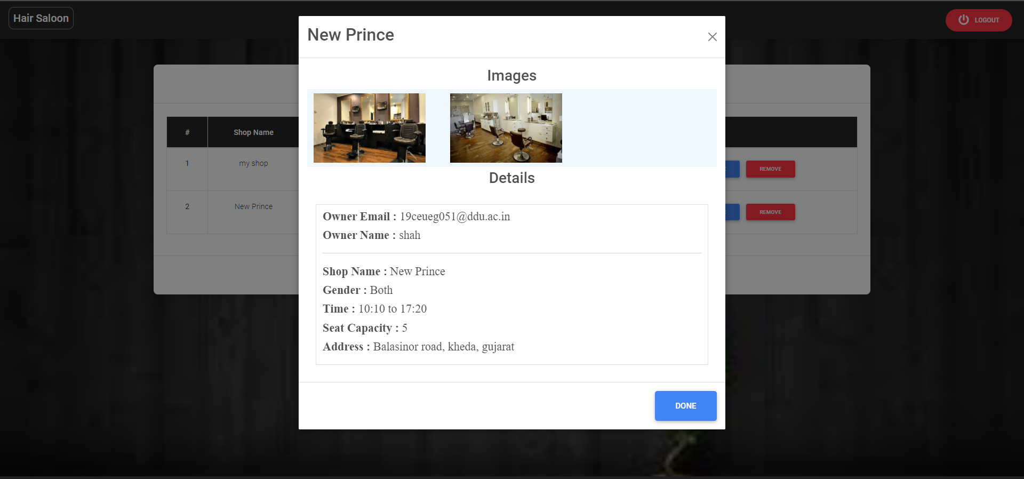

# **Conclusion**

The functionalities are implemented in system after understanding all the  
system modules according to the requirements. Functionalities that are  
successfully implemented in the system are:

* Customer Registration / login (with all validation)
* List nearby salon
* Book appointment
* Order history
* Rate order
* Owner Registration / login (with all validation)
* Manage Services/Employee/Customer
* Edit salon
* Admin login
* Inspect and verify salon

# **Limitation and Future Enhancement**

* In our system to list near by salon we have compared location of every salon instead of that we can improve it by only comparing specific range of longitude and latitude.
* In our system we can also include payment module.
* We can also display statistics of rating.

# **Reference / Bibliography**

Following links and websites were referred during the development of this project:

* [Stackoverflow](https://stackoverflow.com/)
* [Npmjs](https://www.npmjs.com/)
* [React](https://reactjs.org/)
* [MDBReact](https://mdbootstrap.com/docs/react/)
* [Cloudinary](https://cloudinary.com/)